Why do we give presents at Christmas?

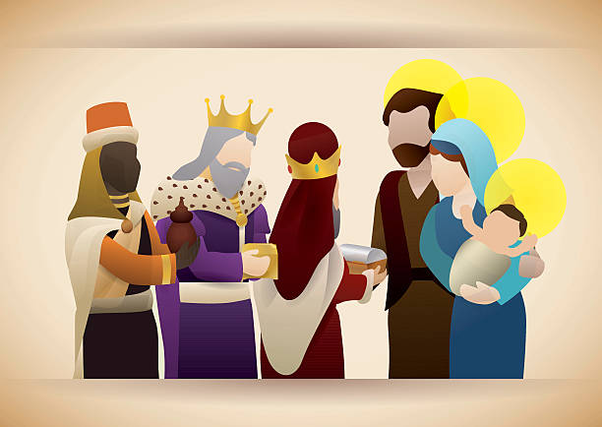
Label what you can see in the image below.
If you could give a family member any present possible, what would you give and to who?
To Christians, the gifts given at Christmas symbolise the three gifts – gold, frankincense and myrrh – given to baby Jesus by the Wise Men during the story of the Nativity.
Gift giving at Christmas isn’t a practice which is exclusive to Christianity though as several other religions mark the end of the year with a similar tradition. For example, the Jewish festival of lights Hanukkah or the Hindu celebrations of Pancha Ganapati in honour of Lord Ganesha.
However, the tradition of gift giving began long before Christianity was even found. It has been suggested that it began with the Romans and their ancient festivals. One festival, Saturnalia, saw private gift-giving, continued partying and a celebratory atmosphere. During this feast, slaves and masters were considered equal and free speech was encouraged.
- Find and copy the three gifts given to baby Jesus by the Wise Men.
- Give an example of another religious festive in which gifts are given.
- True or false, gift giving began with Christianity?
- What is meant by ‘free speech’?

