A summary of Prince Charles’ life  Prince Charles is the eldest son of Queen Elizabeth II and the heir apparent to the British throne. He was born on November 14, 1948, and was christened Charles Philip Arthur George. As a young boy, he was educated at home by private tutors and later attended school in Scotland and Australia. He went on to study at Trinity College, Cambridge, where he received a degree in archaeology and anthropology.  Prince Charles has been an active member of the royal family for many years, carrying out hundreds of public engagements each year. He is known for his interest in environmentalism and has been a vocal advocate for sustainability and conservation for several decades. In 1981, he married Lady Diana Spencer, with whom he had two sons, Prince William and Prince Harry. The couple divorced in 1996, and Diana tragically died in a car accident the following year.  Despite the personal challenges he has faced, Prince Charles has continued to dedicate himself to his royal duties and charitable work. He has established a number of charitable organizations, including The Prince's Trust, which helps young people in the UK who are facing difficult circumstances. | 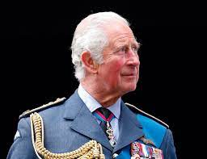  Retrieval Questions:  - Who is Prince Charles?  - When was Prince Charles born?  - What is Prince Charles known for?  - What is The Prince's Trust?  Inference Questions:  - How do you think Prince Charles' interest in environmentalism might influence his future role as king?  - Why do you think Prince Charles has been so dedicated to charitable work?  - How do you think Prince Charles' life might have been different if he had not been born into the royal family?

